Week 7: Spacial data and basemap – PART I DUE FRIDAY October 17, 2008

Last week you collected attribute data for locations on campus. This week you will begin to make a basemap on which to plot those features. For this exercise, you will find aerial photos from the Kentucky Division of Geographical Information website. The URL for this website is http://kymartian.ky.gov/

Once on the website you will see a list of File-based data resources.

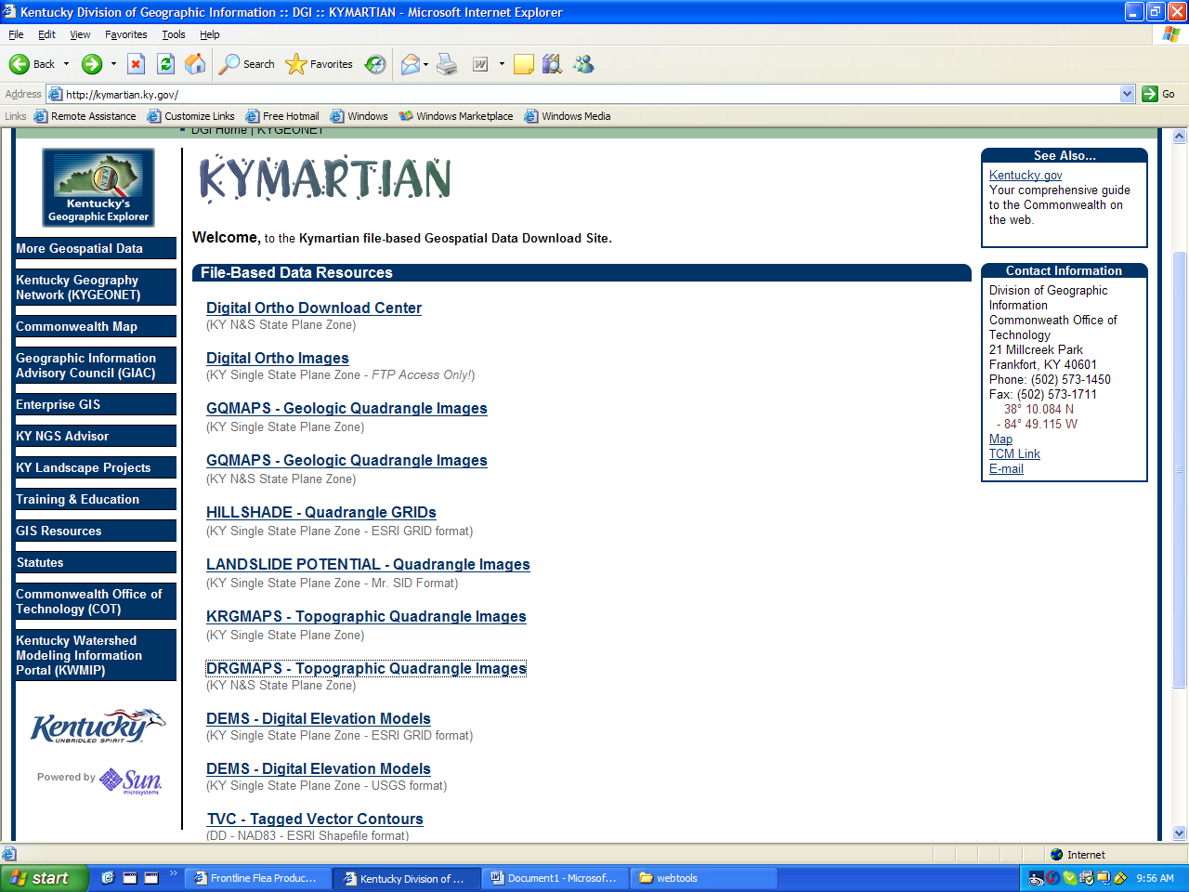
Figure 1

You will be working with the DRG TOPOGRAPHIC IMAGES. Be sure to use KY N & S State Plane Zone sections.

Click on DRG TOPOGRAPHIC IMAGES and you will get the following:

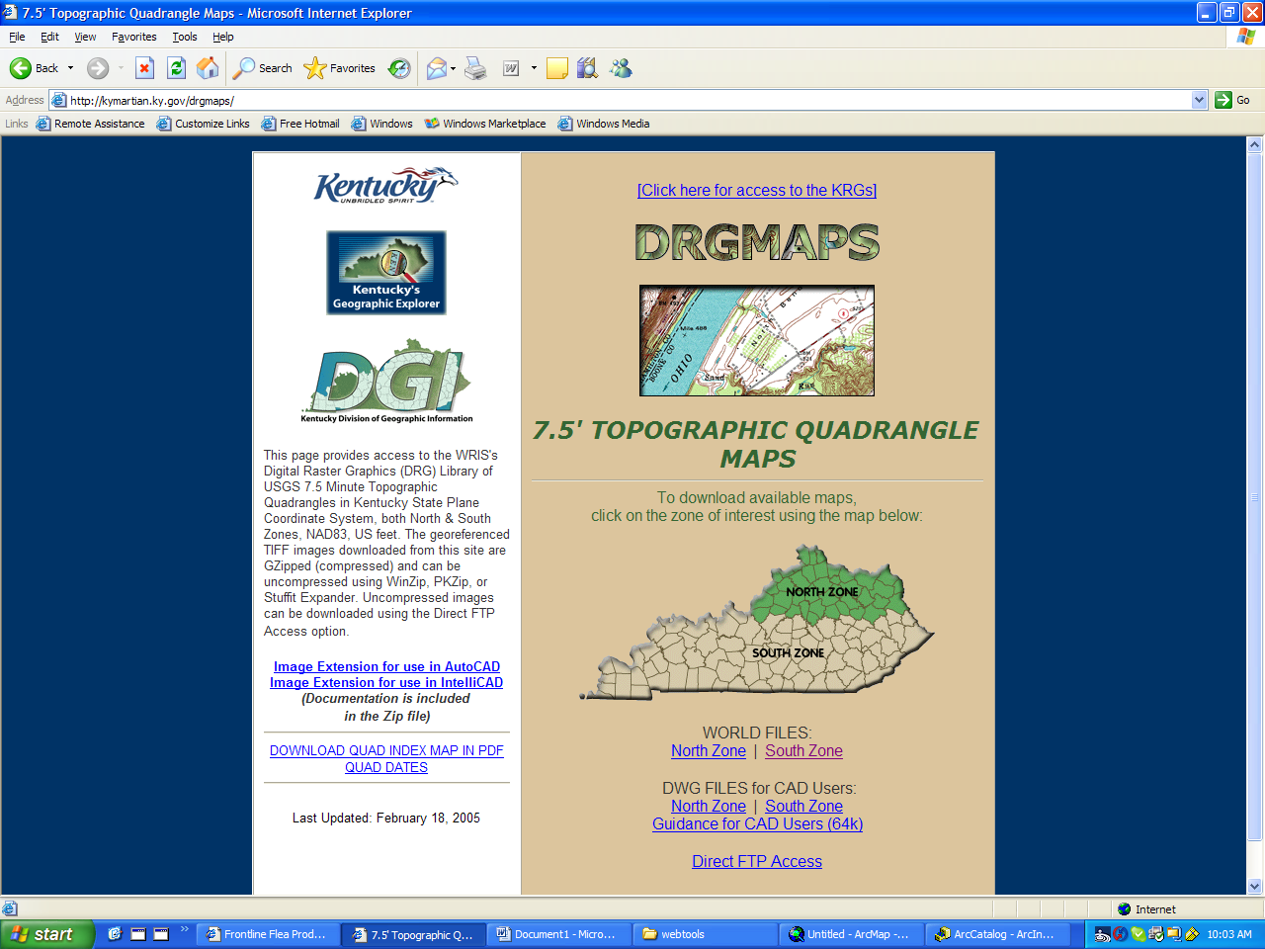
Figure 2

When you click on SOUTH ZONE you will get the following:

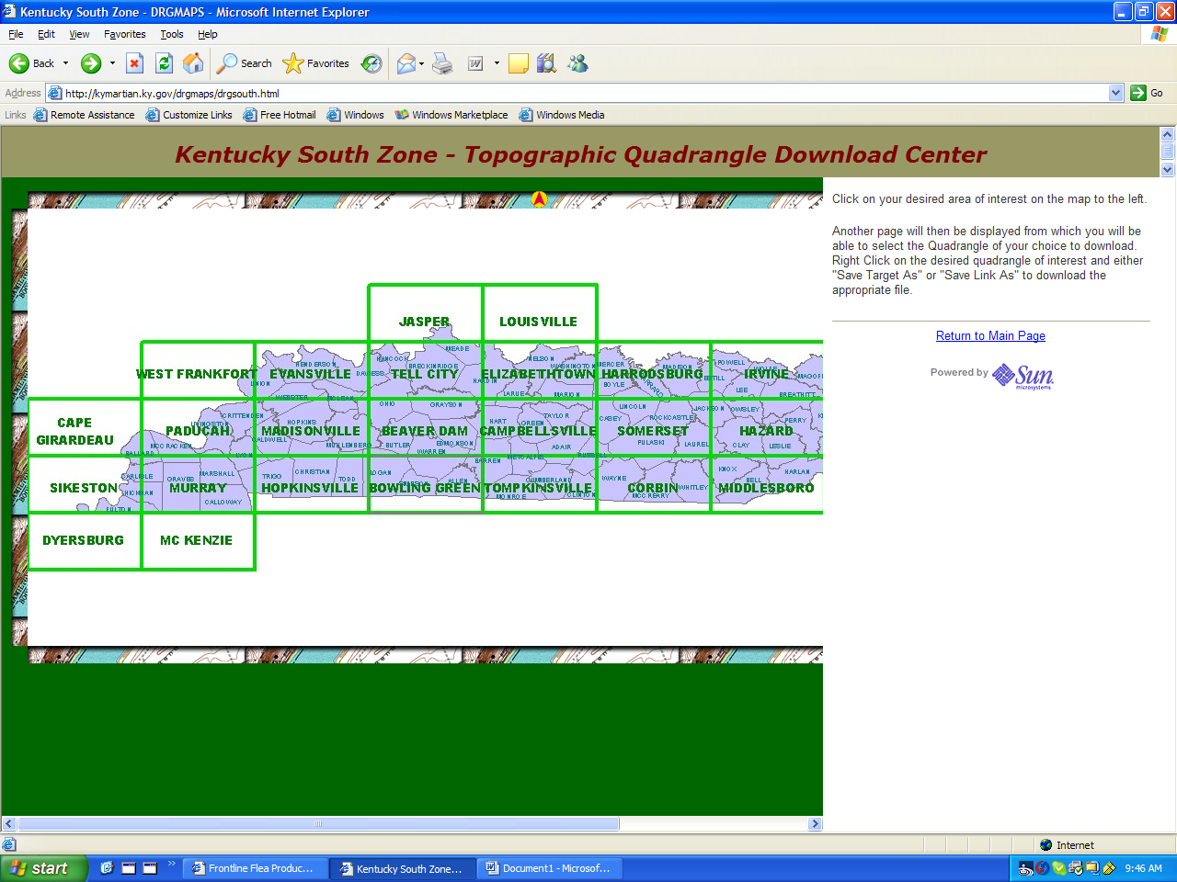.
Figure 3

The topographic map that you need is in the BOWLING GREEN SECTION. Click on that section and you will get the following:

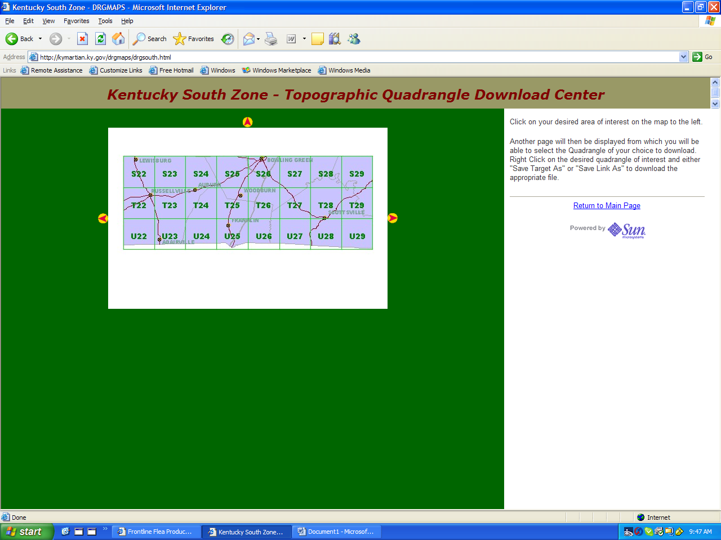
Figure 4

Each section is named with a letter and a number. You need to figure out which section holds the topographic quadrangle that covers Bowling Green. When you double click on the section that you need you will get the following:

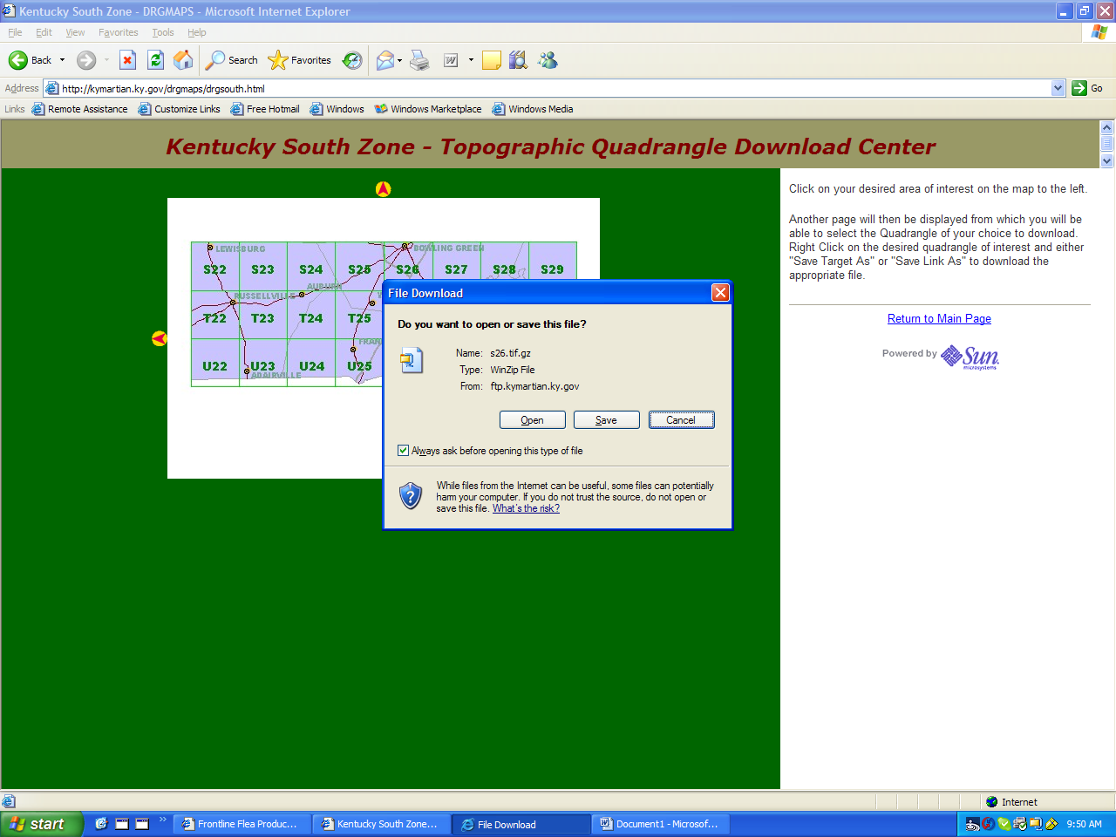
Figure 5

Click on save and it will ask you where you want to save this map. You should save it to a project folder (call it Project 1). The file is in a compressed format and you will need to decompress it. You should be able to do this by double clicking on the file. Whatever unzip software is on your computer will ask you where you want to save it – obviously you will want to save it somewhere in your Project 1 folder.

Open ArcCatalog and double click on the file that you saved. Look at its properties, specifically at “spatial reference”. You will notice that it is undefined. To define it do the following:

Open ArcToolbox.
Scroll down until you find DATA MANAGEMENT TOOLS. Click on that.
Scroll down until you find PROJECTIONS AND TRANSFORMATIONS. Click on that.
Scroll down until you find DEFINE PROJECTION. Click on that. A window will come up that asks for the following:

Input dataset or feature class. Use the browse button (the little folder graphic on the far right) to find the topographic map that you downloaded and unzipped.

For Coordinate System click on the button to the far right. You will get the following window:

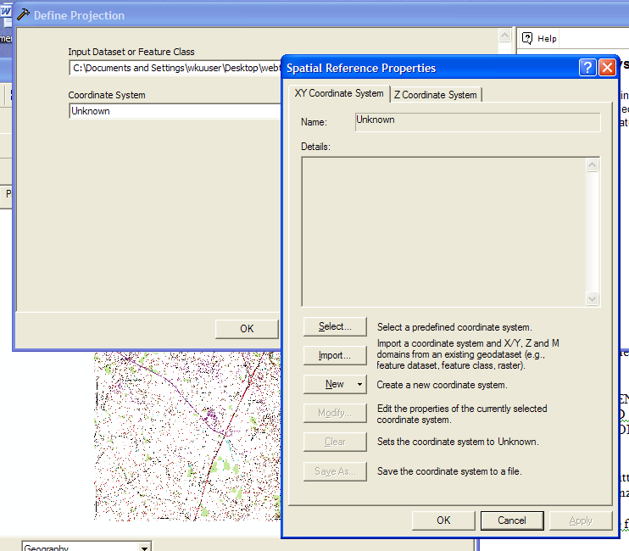

Figure 6

Click on SELECT. Choose PROJECTED COORDINATE SYSTEMS
Next choose STATE PLANE
Next choose NAD83 in feet
Next choose NAD 83 State plane Kentucky South
Click OK.
Another small window will come up that says that the transformation has been completed. Click close.

Now, go back to ArcCatalog, and click on the file for which you just defined the projection and look at properties, then spacial reference. It should now say NAD 1983, State Plane Kentucky South.
You can use this file as your “import coordinate system” file for the DOQ’s that you are about to download.

Open ArcMap, make a NEW map, then use the add data button (the yellow plus), to add the topographic map to your project. Be sure that the map is set on “relative paths” and then save it as WKU.mxd.

Change the scale on the map to 1:24000 and use the “hand” tool to center WKU on the map. Export the map as a jpg. (File, export map, name it wku.jpg).

Put this map in a word document. In that document include the extent of the map, the spatial reference, list the projected and the geographic coordinate system. How many attributes does this map have? What is the uncompressed size of this map?

You can find all of the above info either by looking at the properties in ArcMap and/or by looking at the meta data in ArcCatalog.

Post the word document to your website and label it basemap1.

