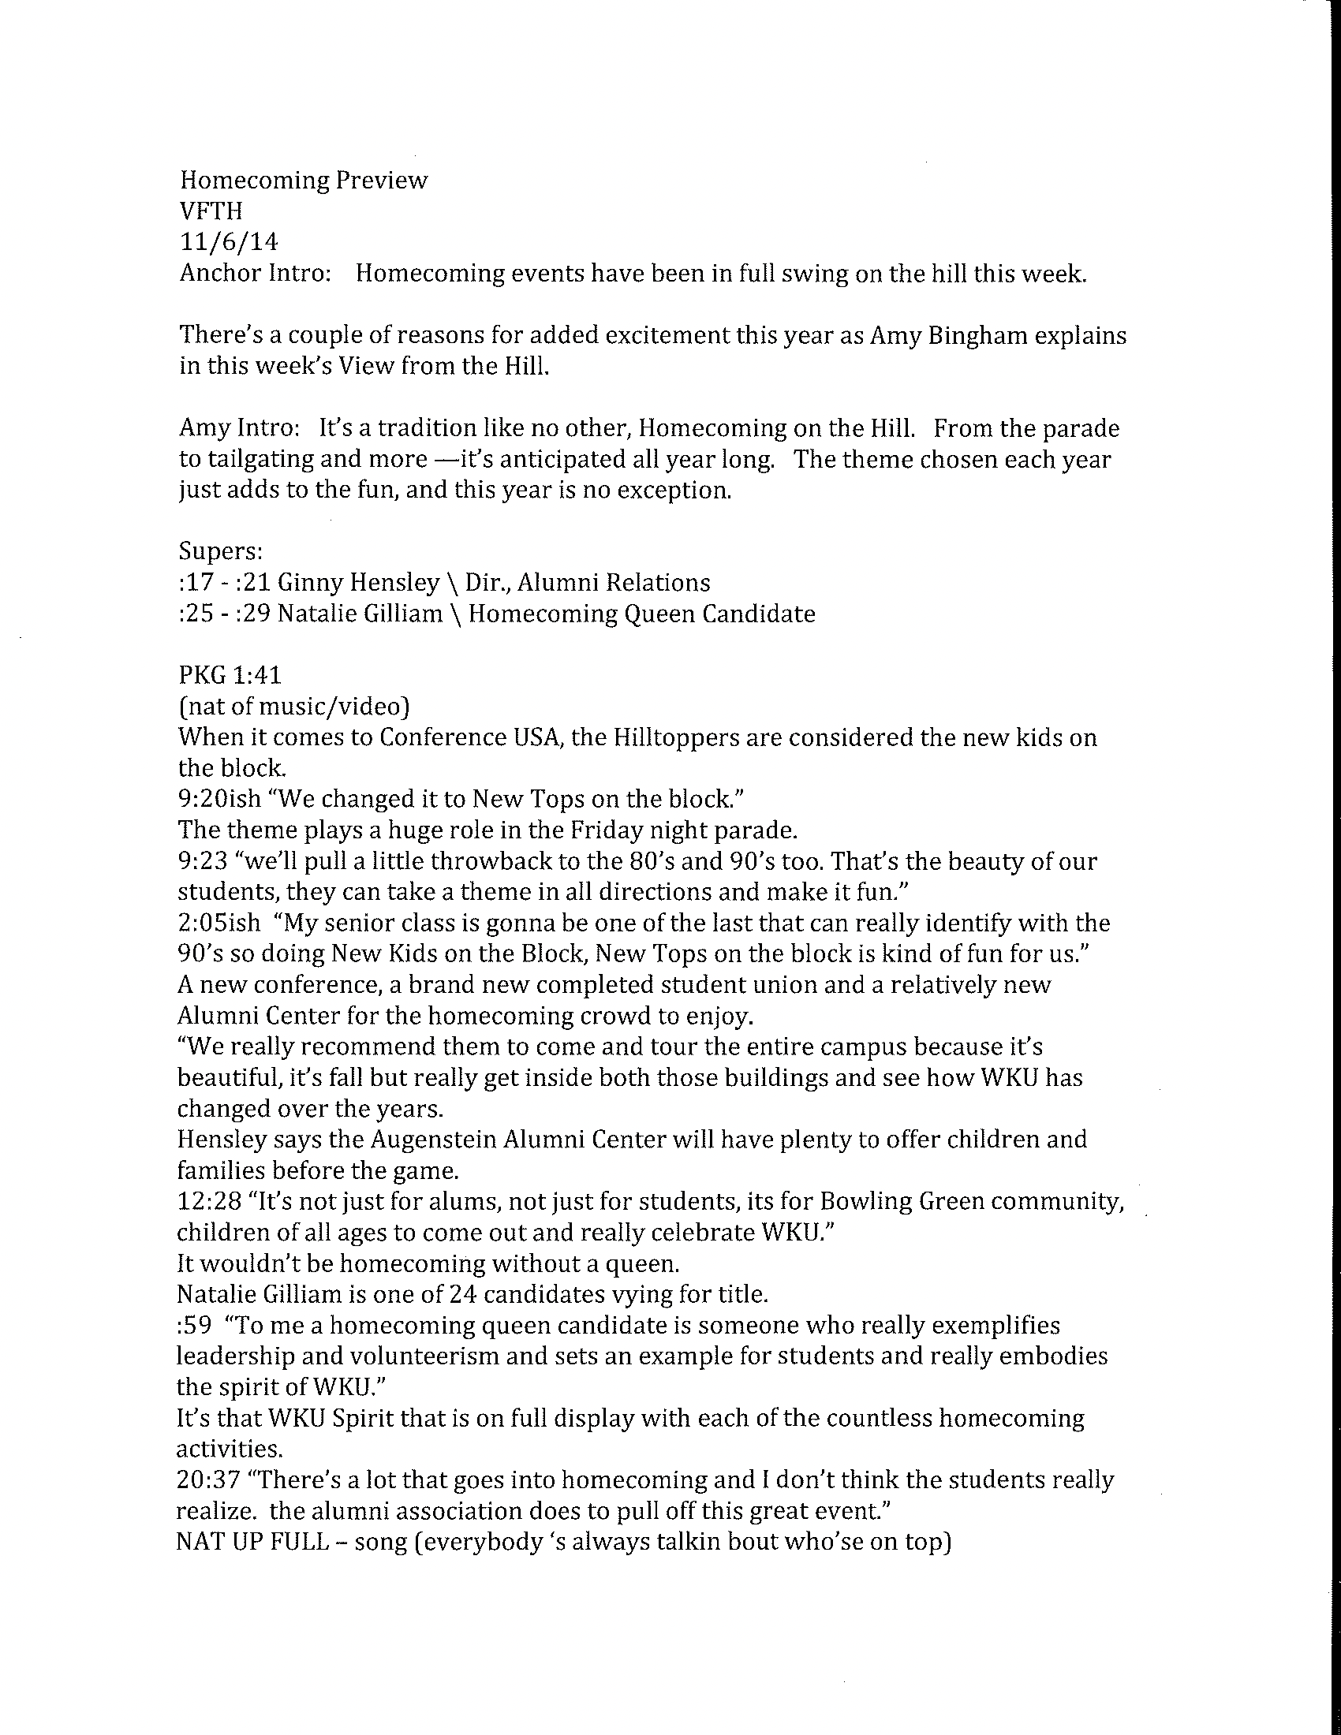
Tomorrow’s homecoming events include Hall of Distinguished Alumni Luncheon and the parade that starts at five on campus. Tailgating begins at 11:30 on Saturday followed by kickoff at 3 pm when the Hilltoppers take on UTEP. And don’t miss the 5th Quarter concert Saturday after the game at the Augenstein Alumni Center featuring the Jordan English Band. With this week’s View from the Hill, I’m Amy Bingham.
###

