**Account Manager Instructions**

You will access the billing with the following link. [telebill.wku.edu](http://telebill.wku.edu)

Username & password is the same as your NetID

Once you are in the system you will notice a drop down to the far top right.

You will have ‘Customer’ & ‘Account Manager’ (Customer allows you to look at your information; Account Manager allows you to view the department billing)

From the Account Manager option select Accounts from the menu

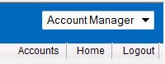

This will bring up the Account Billing page

To view an index, put that index number in the Account Number field

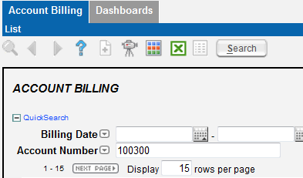

Select Search

You will get only the billing for that index.  (you can also change the rows per page if needed)

You can also narrow the search by date.

Select the billing date you would like to see for billing details. The Account summary page will appear

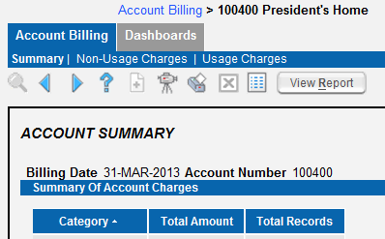

Either you can select View Report; which will bring up a separate window with billing detail

Or…

Select Non-Usage Charges; which will show any MRC (Monthly Recurring Charge) or OCC (Other Charges & Credits) charges for that billing period.

Usage Charges will show call records.