Western Kentucky University
Employee Tax Forms
How to Consent to Receive W-2 Electronically
Payroll Department
11/23/2010

HOW TO CONSENT TO RECEIVE W-2 ELECTRONICALLY

- Log in to your TOPNET account.
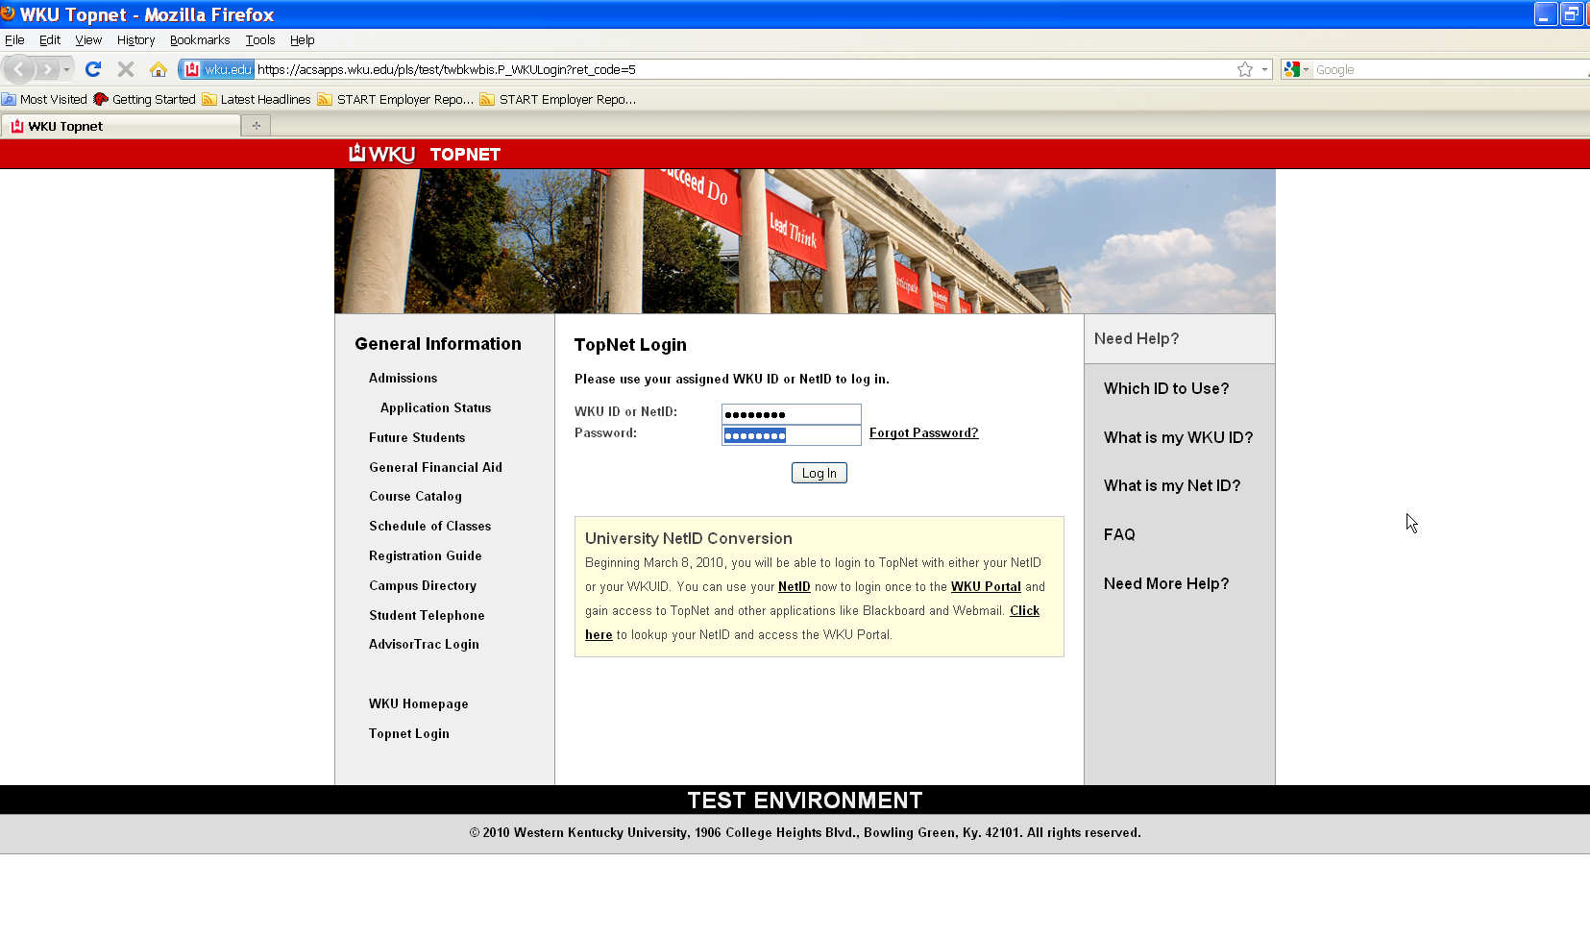
- The next webpage is “WKU Employee Bulletin Board.” Click Continue Login. 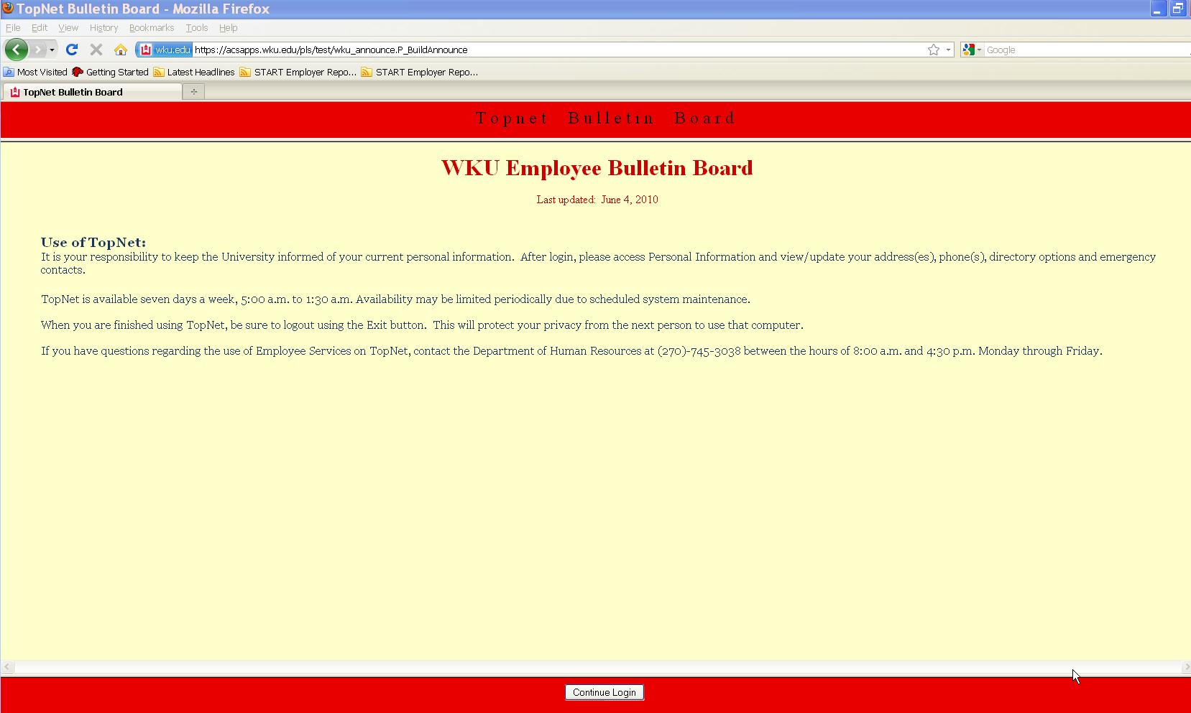
- This webpage is the Main Menu for TOPNET. Click on the Employee Services option under the “Welcome to TopNet!” message. 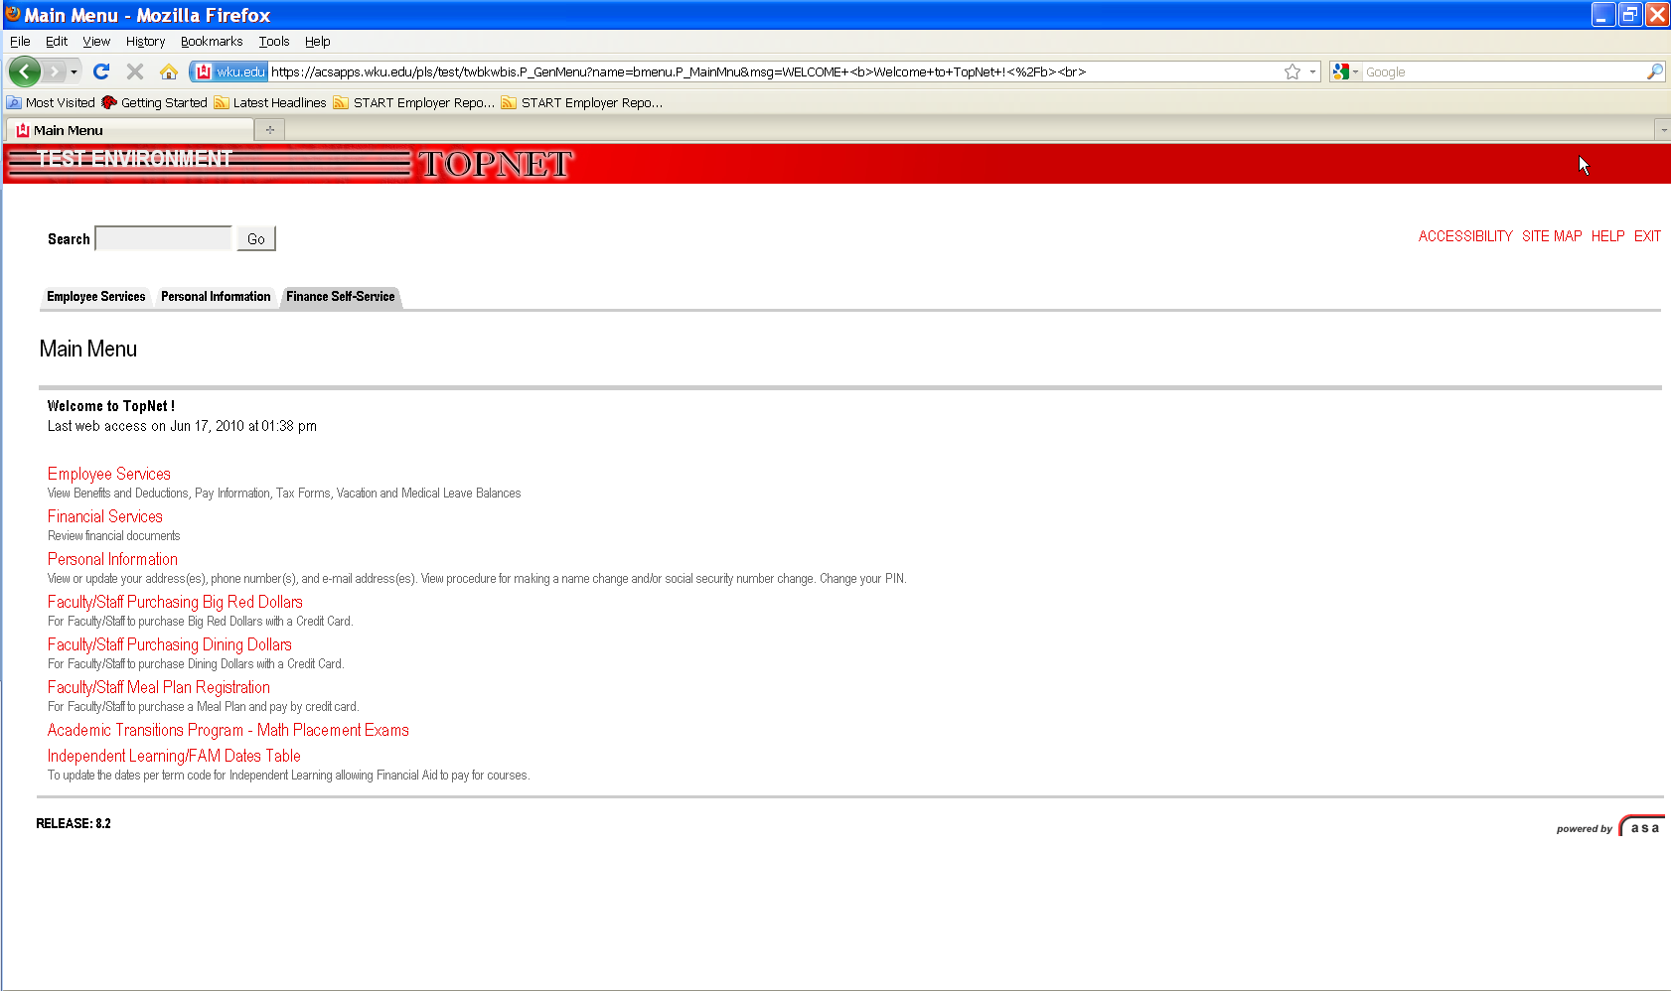
- This webpage is Employee Services. Please be sure you are on the Employee Services tab of the webpage. Click on Tax Forms.
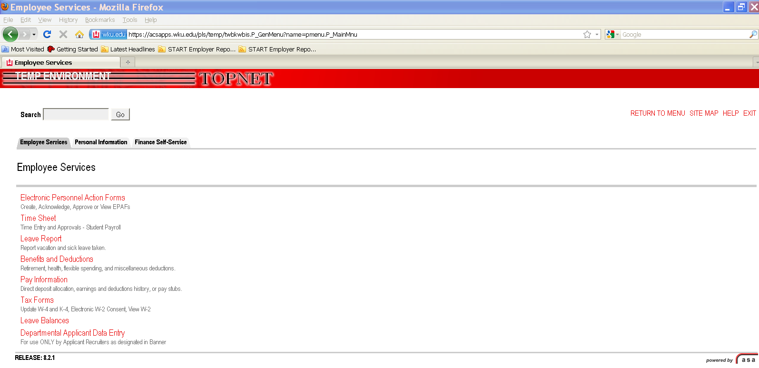
5. This brings you to the Tax Forms page. Click on Electronic W-2 Consent.
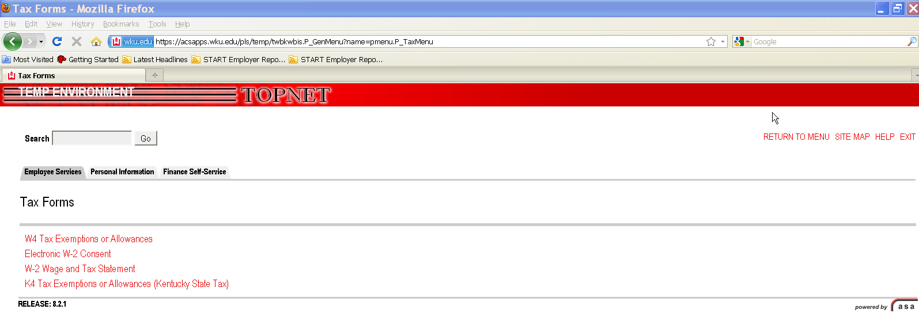
- To consent to receive your W-2 electronically, check the box next to Consent to receive W-2 electronically. To revoke your election, uncheck the box next to Consent to receive W-2 electronically and click on Submit.
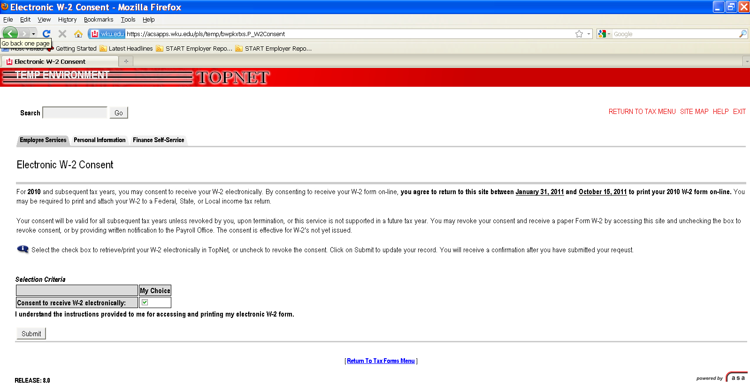
7. After you have submitted your election the next webpage will be displayed which will be the Electronic W-2 Consent Confirmation. From here you may exit the form.
