Part 1 – Getting Started With Mediasite

Accessing Mediasite
- Go to the Mediasite portal (https://mediasite.wku.edu/Mediasite/mymediasite)
- Login using your NetId

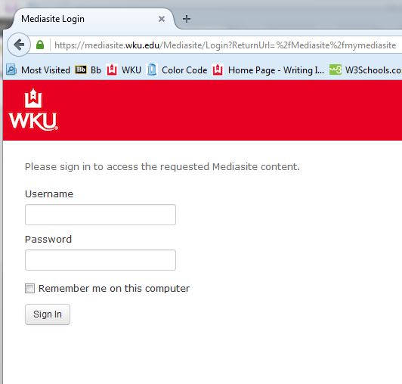

Registering Mediasite
- After you login for the first time you will be prompted to complete your user profile to begin the registration process. Fill out the form with the appropriate information as follows:
- For "Name," include your first and last name. For example, Jane Smith.
- For "Email Address," use your WKU email address.
- For "Local Time Zone," select your time zone.
- Select "Continue".
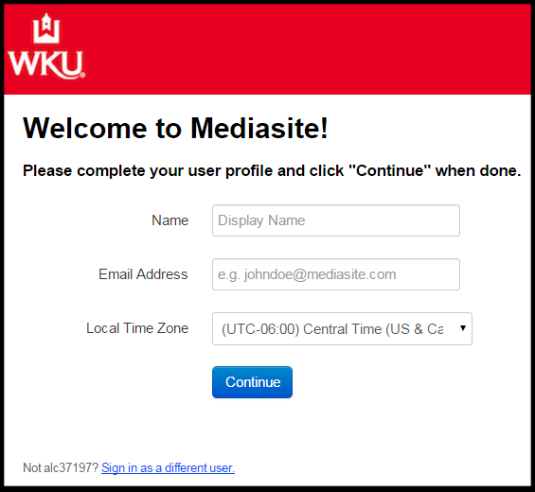
- Open your WKU Email.
You will receive an email from mediasite@wku.edu with a link to complete the registration process and activate your account.
- Click on the link in the email.
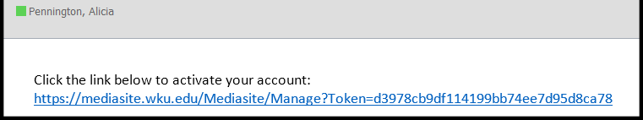
- Close the Mediasite window that opens as a result of clicking the link in the email.
- Return to Blackboard and click the “Continue to Mediasite” button.

This will be the first screen you will see:
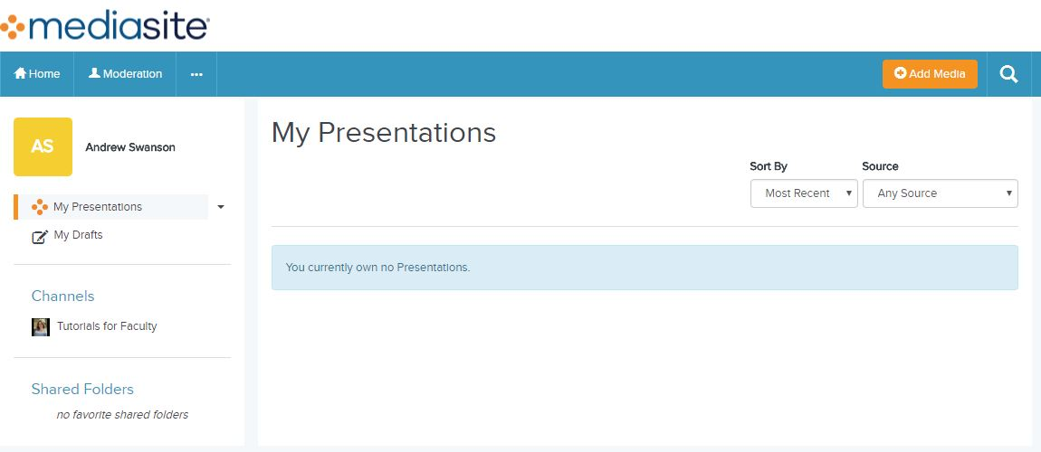

Downloading Mediasite Recorder
You will need to download the Mediasite Recorder onto each computer you use to record Presentations.)
- To download the Mediasite Recorder click the “Add Media” button from the homepage.
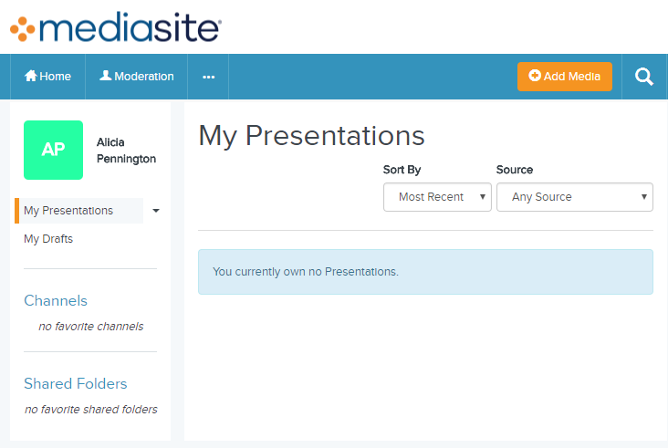
- Click “Download the Mediasite Desktop Recorder”.
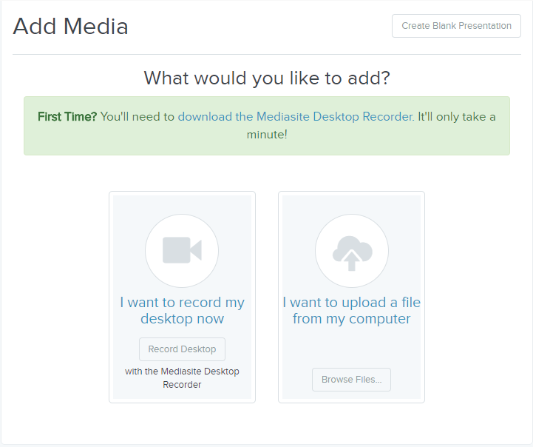
An internet window containing the 3 steps to download the Mediasite software will appear. Begin with step 1.

- Click "Download for Windows" or “Show me the Download for Mac”..
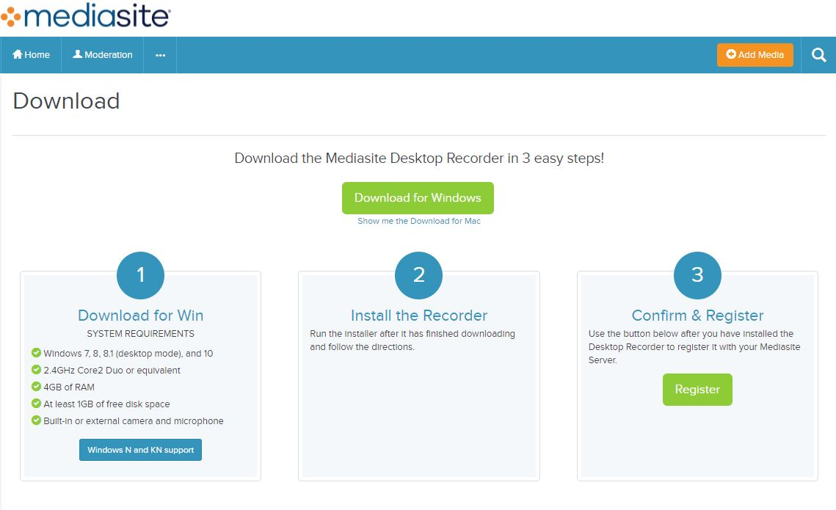
- Run the “.exe” or “.pkg” file that was downloaded.
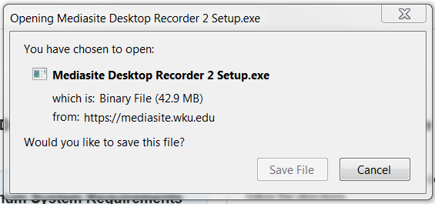

- Follow the installation prompts to allow the Mediasite Desktop Recorder to be installed.
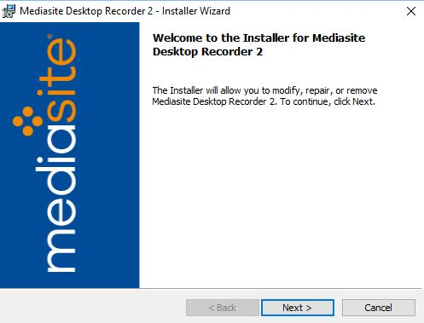

- To complete the installation process, select the “Launch Mediasite Desktop Recorder 2” box and select the “Finish” button.
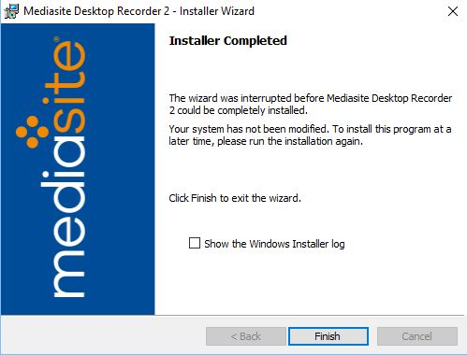
Once you have finished installing the program, the Mediasite Desktop Recorder window will appear. You will not do anything in this window.
- Return to the 3 Easy Steps to install Mediasite website.

- Click the “Register” button located under Step 3.
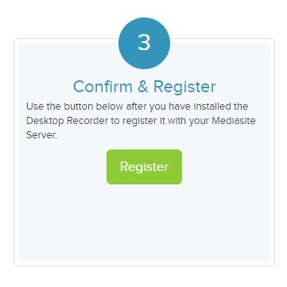

NOTE: When you click the “Register” button, a “Launch Application” dialogue box might appear. If it does,
- Check the box next to “Remember my choice” so that this Launch Application box does not appear again.
- Click "OK" in the Launch Application box.
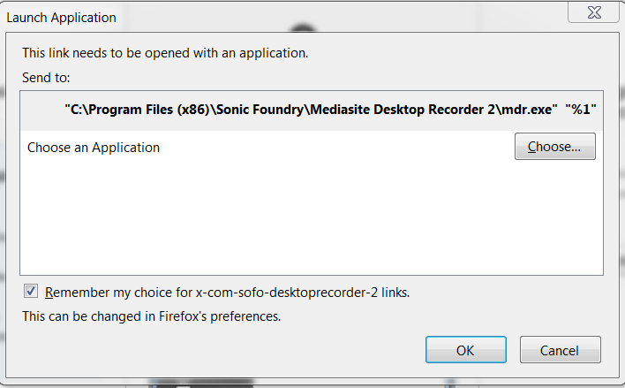

- You will receive two notifications on your desktop confirming the registration process is complete.
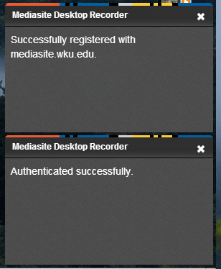

Checking Profile Information
- At the homepage of Mediasite, update your profile information. Click “…” and then select “My Settings”.
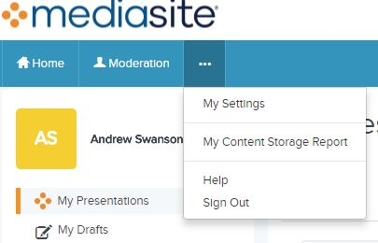

- Check to ensure all information is correct. You also have the option to change notification settings and your Presenter Information. Once finished, click the “Save” button.
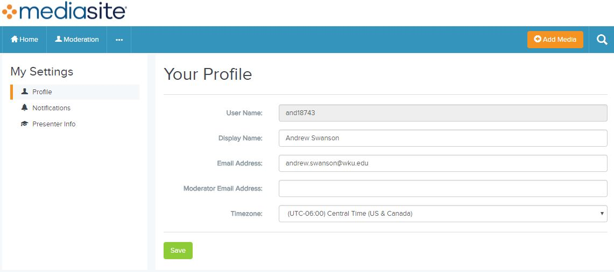

Part 2 - Working In Mediasite

Recording Presentations
To create a presentation, selection the “Add Media” button in Mediasite.
Select the “I want to record my desktop now” option.
Name your recording, add a description if applicable, publish to the appropriate channel, and click “Create and Launch”.
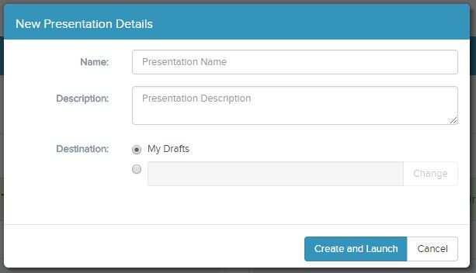

The recorder window will pop-up. Select the “Record Now” option.

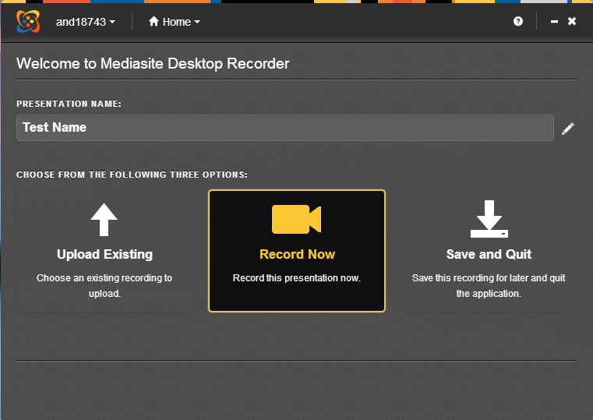
- Choose the type of presentation you wish to record.
- Screencast + Video: Choose this option to show a website, such as your Blackboard course; annotate in PowerPoint or Word; or demonstrate a process. This option also records your image from your webcam.
- Screencast + Audio: Choose this option to show a website, such as your Blackboard course; annotate in PowerPoint or Word; or demonstrate a process. This option only records your voice (audio) from your webcam or microphone.
- Slideshow + Video: Choose this option when you want to show a PowerPoint presentation. This option will allow you to change PowerPoint slides after you've finished recording, as long as the audio does not change. This option records your image from your webcam.
- Slideshow + Audio: Choose this option when you want to show a PowerPoint presentation. This option will allow you to change PowerPoint slides after you've finished recording, as long as the audio does not change. This option only records your voice (audio) from your webcam or microphone.
- Click the right-facing arrow (highlighted in red in the below image) to scroll through the presentation options.

- Click “Next”.
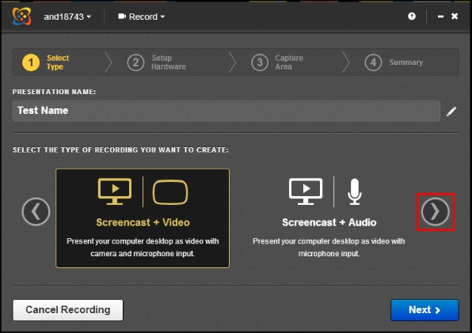
- Select the hardware you wish to use for the recording if Mediasite does not automatically select the correct hardware for you.
- The “Camera Size” will automatically be detected based on the web camera connected to the computer.
- Select the “Camera Input” drop down box and select the appropriate camera. Make sure your image appears in the preview window.
- Select the “Microphone Input” drop down box and select the appropriate microphone. Check the audio levels to the right of the preview window to make sure they are at a good level. Do this by speaking at the volume in which you will be recording. This should be in the upper green area.
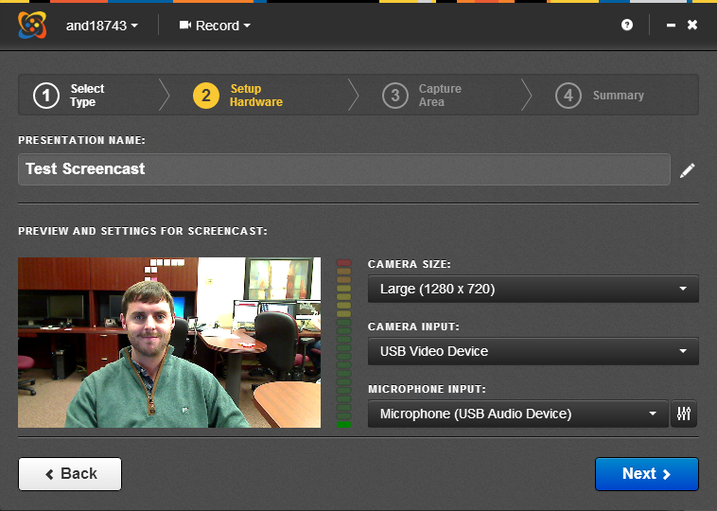
- Click “Next”
- Select the appropriate recording area for the presentation:
- Click on the “Desktop” drop down box to select the entire desktop.
- Select your desktop from the drop down box. In this case, we selected "Desktop 1 (1920x1080)". Your selection may look slightly different.
- Click the green check mark button to finalize the region selection.
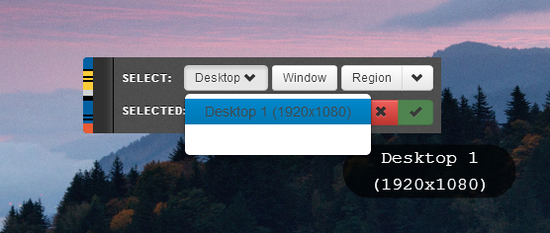
- The summary page will appear which will give information about the recording before you start recording. Check to make sure all of the specifications are correct. In the bottom of the summary page it tells you how to pause a recording once you start the presentation.
- Once you are ready to record, Click “Record”.
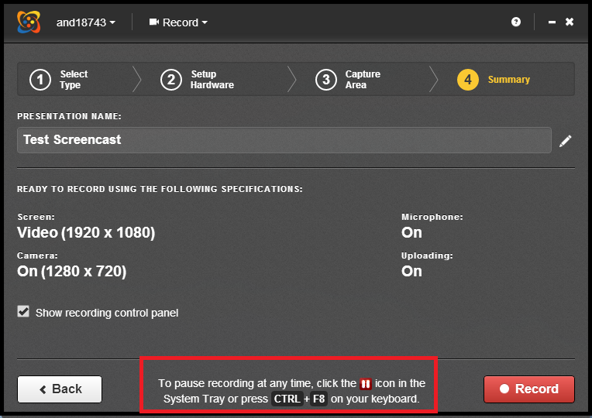
You will get a 5 second countdown before recording begins.
- Minimize the Recording Control Panel (image below) or move it to a second screen, if that option is available to you, so that the window will not show up in your recording.
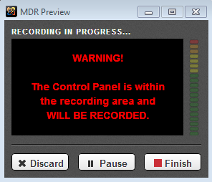
- You will have the option to discard, pause or stop your recording.
To stop or pause the recording if you minimize the Recording Control Panel:
Click the red pause button found in the bottom right-hand system tray on a PC or the upper right-hand side of a Mac.
PC image
Mac image

To stop or pause the recording if you moved the Recording Control Panel to another screen:
- Click Discard - delete the presentation
- Click Pause - temporarily stop the presentation recording
- Click Finish - end recording and begin the upload process
If you pressed the Pause button, the Recording Paused box will appear. Choose which action you wish to take:
- Click Discard - delete the presentation
- Click Resume – resume your recording
- Click Finish - end recording and begin the upload process
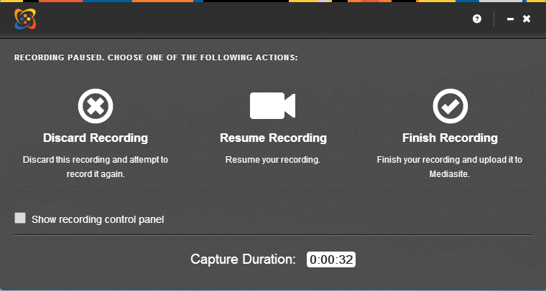
Once you click Finish, the recording manager will open and show you the uploading progress of your recording.
NOTE: DO NOT DELETE VIDEOS FROM THIS MANAGER. IT WILL REMOVE THEM FROM YOUR LOCAL COMPUTER.
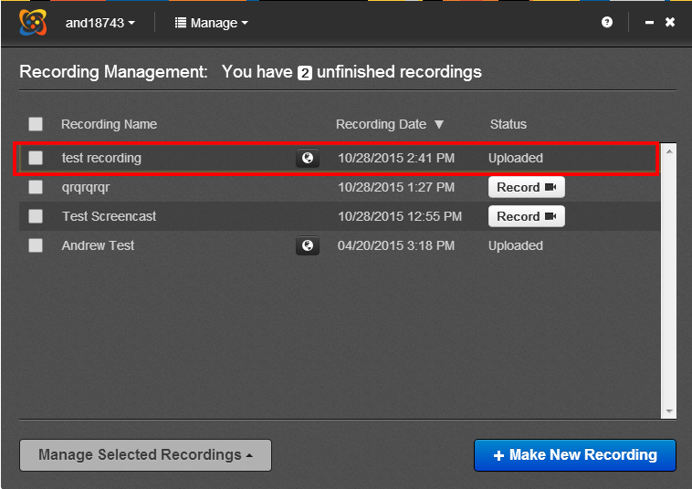
- Click the “X” in the upper-right-hand corner to close the Recording Management.
- Return to Mediasite to find the newly-recorded presentation open. Although it looks like your presentation has not uploaded to Mediasite yet, it has. It will take a minute or two to sync. You might need to refresh your page or click a different folder, such as Everything or Drafts, to be able to see the video.

Making Presentations Viewable
In Mediasite you will see the most recently created screen recording. This recording will be in the channel you previously designated. For others to view it, you will need to change the view settings to “Viewable”. If you would like to keep it private, leave the “Private” option selected. If you keep the video as private, you are the only one who can see the video. To make this change click on the “lock button” on the lower right part of the thumbnail. If the lock is “open” it is viewable. If the lock is “closed” it is private.
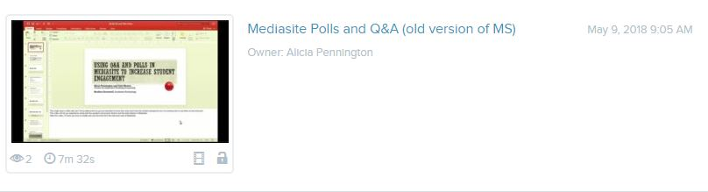

Sharing your presentation link
In order to share your video you need to copy the url address of your video. To share your Mediasite video using a web link, open My Mediasite. Select the video you want to share.
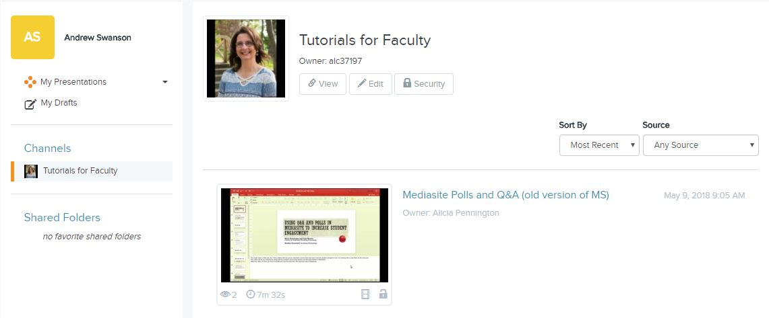

Scroll to the bottom and click the “Share Presentation” button.
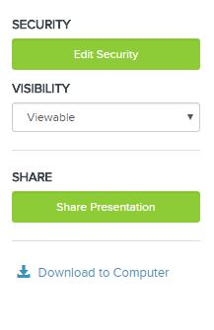
Highlight and copy the link.
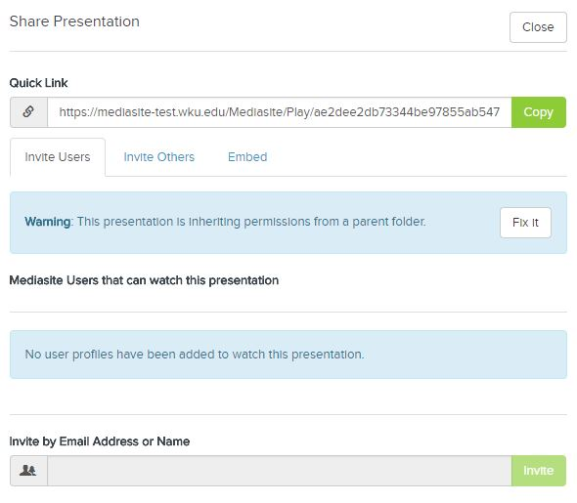

Post the link in Blackboard in the designated area. It may be an assignment, discussion board, blog or a journal. Faculty and students will login using their NetId to watch the video.

