Rain Barrel Placement

Rain barrels are often installed near your gutter downspout. Cut the gutter to the desired height to match your installed rain barrel and install a gutter elbow to direct the water into the intake bucket. It is important that your rain barrel be installed on a flat, stable surface to sit upon. We suggest leveled concrete blocks (see below).

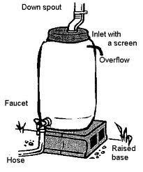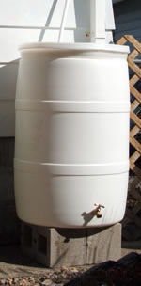

Connecting Your Rain Barrel

Connect main garden hose to bottom spigot. Remember it is important to elevate your rain barrel (see diagram above) as gravity is the force that moves the water out of your barrel and into your hose. We also recommend connecting a short hose to at least one of the runoff connectors (cap the other if not using two hoses). This allows you to control where excess water goes and assists in keeping out insects.

Rain Barrel Maintenance

Like most things around your home, your rain barrel needs a little regular attention to keep working smoothly. The following are tips to keep your rain barrel in the best shape possible:

(1) Periodically inspect your barrel for cracks or debris buildup. Light colored barrels that are in direct sunlight may become brittle over time. They can be painted to make them last longer.

(2) Empty your barrel monthly.

(3) Clean your gutters regularly to reduce debris.

(4) Once a year, tip it over during a dry spell and rinse it out with a hose.

(5) Don’t let rainwater sit in your barrel longer than a month if smell is a concern to you or if you start accumulating algae. You can also put a capful of chlorine bleach into the water. That small amount won’t hurt plants, but vinegar might -- don’t use any type of vinegar in your rain barrel.

(6) Be sure the base is level and solid as the weight of a full rain barrel can reach upwards of 400 pounds.

(7) If you have trouble getting the water to come out, remember to keep that hose attachment area clear. Remove the water hose and use a wooden or metal skewer or ice pick to clear out any debris. You can also try adding cheesecloth or muslin on top of the screen to act as an additional filter. If this does not help, you may need to elevate your barrel to get more help from gravity.

(8) If your rain barrel springs a small leak, most can be repaired with aquarium caulk, a clear sealant available at most hardware stores.

(9) Use a small hose or cap attached to the runoff connectors to ensure no insects get in the rain barrel through the connector itself.

(10) To winterize your rain barrel, there are a few different measures you will need to take. First you will want to disconnect the downspout. Return the downspout to its original configuration prior to the rain barrel. Remove the hose and mesh screen and store them. Make sure to drain the rain barrel – this will help prevent it from freezing and cracking. Lastly, you will want to store it upside down, so no water or materials will be able to enter.

