Rain Barrel Making 101
(An Informative Resource and user guide)

This handbook was developed to accompany a workshop held in an effort to promote energy and water conservation through the use of rain barrels. The workshop was co-sponsored Western Kentucky University’s Center for Environmental Education and Sustainability and WKU’s Office of Sustainability. The project was conceived, organized, and facilitated by students in Dr. Terry Wilson’s class, ENVE 560, Investigating and Evaluating Environmental Issues.

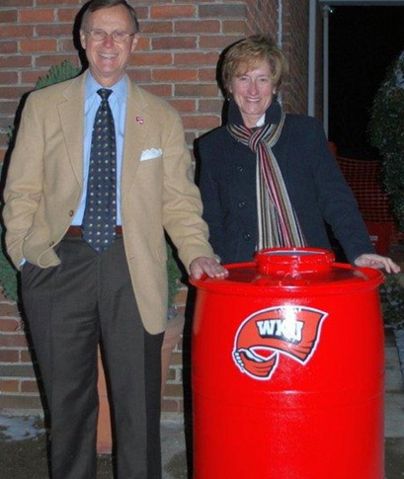

Rain Barrel Users Guide Contents

- Rain barrel project history, information, and rain barrel FAQ.
- Rain barrel construction materials list.
- Rain Barrel step-by-step building guide.
- Rain barrel placement and connections suggestions.
- Rain barrel cleaning and maintenance.



WKU History of the Rain Barrel Project

The WKU rain barrel project began last fall in Dr. Wilson’s graduate course ENVE 560: Investigating and Evaluating Environmental Issues. The course is based on a six-step environmental service-learning program known as Earth Force.

“The graduate students inventoried issues on campus and after examining the resources available and the area with the most need, they decided that water management is a major issue that needs attention,” Dr. Wilson said. “This came after some research they did to find out that large amounts of energy is needed every day to clean our water to drinking water standards, although much of that water is used to flush toilets, wash cars and irrigate gardens.” Working with WKU Sustainability Coordinator, Christian Ryan-Downing, the students obtained 55-gallon plastic barrels from Pepsi Co. and designed the rain barrels. One of the first rain barrels built by the students was delivered and installed at President Gary Ransdell’s home.

When this years group of graduate students began the course this semester, Dr. Wilson asked what service-learning project they’d like to complete. The students decided to continue working on the rain barrel project with some small modifications and then expand the project into the local community as a way to conserve water and energy. The rainwater collected in the barrels can then be used to water plants or gardens. “We’re making something that conserves water and energy and promotes environmental sustainability,” Dr. Wilson said.

A rain barrel is placed under a gutters downspout next to the house to collect rainwater from the roof. The barrel holds about 50 gallons of water, which can be used to water your garden, pets, and any other use requiring water. Harvesting rainwater has many benefits including conserving water, saving money on your water bill, and helping control drainage issues such as basement flooding. By collecting rain water homeowners are also helping reduce flooding and pollution in local rivers and streams. When rainwater runs off of hard surfaces like rooftops, roadways, parking lots, and compacted lawns it can carry with it pollutions to our rivers and lakes. Harvesting rainwater in a rain barrel is just one of the ways homeowners can reduce rainwater from coming off properties and causing pollution and flooding problems.

Rain barrels at garden stores can cost over $100.00, but they are actually very easy and inexpensive to construct on your own. The WKU rain barrel is constructed using recycled food grade barrels and buckets. All materials (the spigot, overflow connectors, and screen) can be bought from local hardware stores for a cost of $20.00 to $40.00.

Rain Barrel FAQ

My roof is small. Is it even worth it for me to have a rain barrel?
For an 800 square foot roof area, in a 1 inch rain, 500 gallons of water will come off of a roof this size. If all of your neighbors install rain barrel it can have a significant impact on flooding and pollution within your community.

What defense will my rain barrel have against mosquitoes and other insects?
A mosquito-proof screen on the lid of the barrel helps prevent the intrusion of mosquitoes and other insects.

What can I do with the water I harvest with a rain barrel?
Water collected can be used to water flowers, shrubs, trees, lawn, and garden. It can also be used to wash your car, rinse hands/feet, tools, shoes, etc. and water livestock.

What precautions should be taken with using a rain barrel?
Be sure you have a solid flat base for your rain barrel to ensure it does not tip over. When full, a rain barrel can weigh around 400 pounds. Always keep the lid to your rain barrel tightly secure to avoid any accidents involving children and/or animals.

Can I drink the rain water from my roof?
Most of the water shouldn’t be used for drinking. Rainwater may contain pollutants, algae and other materials that get washed from your roof. We don’t recommend drinking it.

How do I clean the inside of the rain barrel?
We recommend washing the barrel when disconnecting it for the season. Use an environmentally-friendly solution of 2 tsp. of castile soap + 2 tsp. vinegar or lemon juice per gallon of water for cleaning, swishing the solution around inside the barrel then rinsing the inside of the barrel with a garden hose. A concentrated nozzle spray will work well to remove residue from the inside of the barrel.

I don't like the color-can I paint or decorate my barrel?
The barrels are made from high-density-polyethylene (HDPE), to which is notoriously hard to get paint to stick. We have not found a totally environmentally friendly paint that will adhere to the barrel. There are, however, spray-paint companies that make paint specifically for plastics (Krylon's "Fusion"). We recommend placing 'chicken-wire' around your barrel and training some sort of native vine plant to grow up the wire. Some people have built aesthetically pleasing enclosures for the barrel. Another option is to site the barrel hidden among bushes/shrubs to make it less noticeable.

Rain Barrel Materials
- 55 gallon barrel
- Sm 2.5 gallon bucket w/lid
(Paint Bucket/Icing Bucket)
- Aluminum screen
- 1 inch threaded faucet
- 2 inch threaded brass connector
- Plumbers tape
- Valspar paint for plastics (for better results try using their primer for plastics first)
- 4 Concrete Blocks (for base)

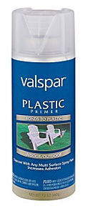

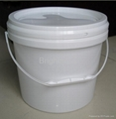
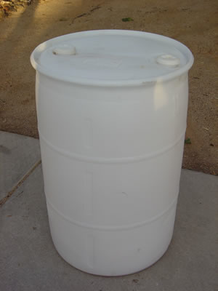
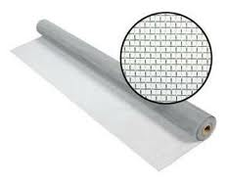
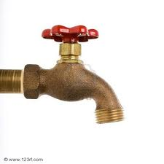
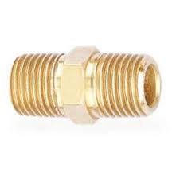
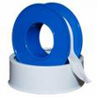
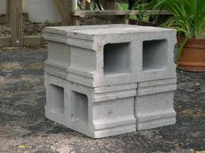
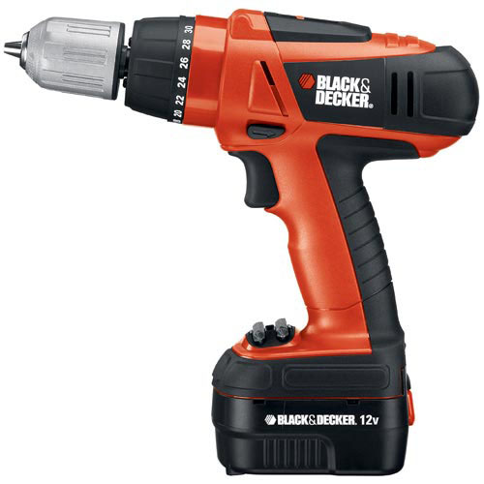
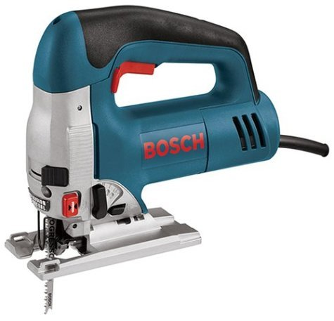
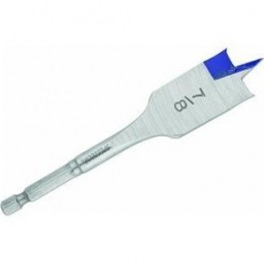
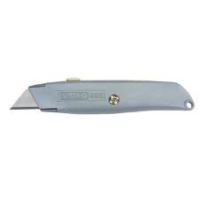
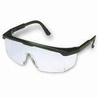
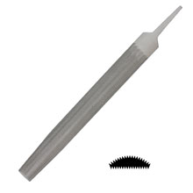
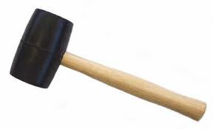
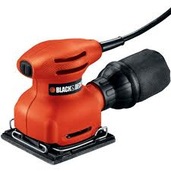
Rain Barrel Tools
Drill
7/8 inch flat bit
1 inch flat bit
Utility Knife
Jigsaw
Rubber Mallet
File
Hand Sander
Eye Protection

