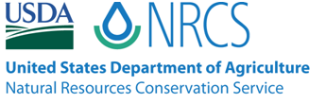
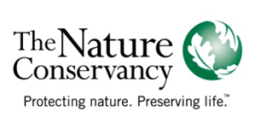
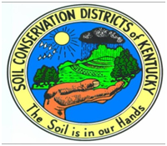

Wetlands Reserve Program Field Representative
Scope of Work

This position is funded through The Nature Conservancy and USDA Natural Resources Conservation Service and sponsored by the Graves County Conservation District.

Knowledge, Skills, and Abilities necessary for position:
1. Working knowledge of wetland ecology (degree in biological sciences not necessary, but beneficial)
2. Proficient skills in database management and Geographic Information Systems (GIS) applications
3. Proficient communication skills (both oral and written)
4. Ability to communicate effectively with diverse groups of people
5. Ability to conduct educational programs with K-12 school groups, civic groups, and the general public
6. Ability to work outdoors in all weather conditions

Duties and Responsibilities of the Position:
1. Assist with Wetland Reserve Program project ranking and preliminary conservation planning activities in both field and office
2. Assist with marketing and outreach of Wetlands Reserve Program and other land stewardship programs available through USDA and other cooperating partners
3. Assist landowners through all phases of application and enrollment into the Wetland Reserve Program
4. Use GIS to create project maps and accomplish conservation planning tasks
5. Manage multiple program databases
6. Assist with monitoring, inspection, and management activities on Wetland Reserve Program easements
7. Assist with conservation practice recommendations in the Graves County Service Center and surrounding counties
8. Assist with completion of compliance paperwork, such as NEPA and Environmental Evaluations
9. Assist with water quality monitoring program
10. Develop and implement conservation education programs in area schools
11. Develop and submit reports in a timely manner

Administration of the Position:
Position will be located in the Mayfield (Graves County) USDA Service Center. Input and guidance for the role and responsibilities of the position will be coordinated between the DOC, NRCS, TNC, and the Graves County Conservation District. The day-to-day assignment and duties will be established by the “Purchase Area” Easement Team Leader, in consultation with the hosting conservation district board of directors, the Lead District Conservationist, and TNC.

TWO YEAR TERM POSITION / STARTING MINIMUM SALARY: $22,000 (Based on education/experience)
NO HEALTH BENEFITS
WRT requirements: 6 days (SICK) and 1 week (5 day) paid Annual Leave with pay.

