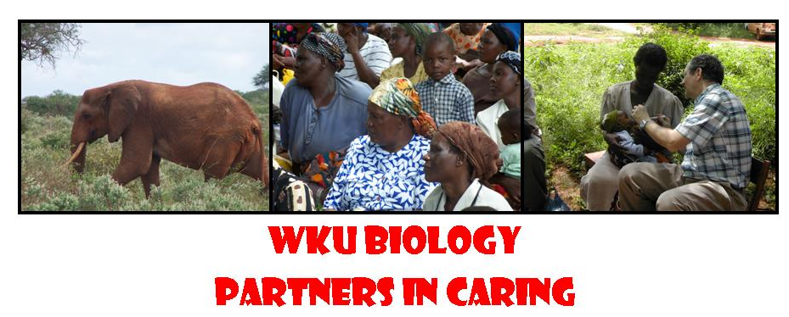
Student Application for
Partners in Caring: Kenya 2012/2013
Western Kentucky University
A Service Learning Course

Name
Email
Phone
WKUID
Address
City/State
Why would you like to be a participant in the 2012/2013 Kenya Medical Experience?

What do you expect to learn while on the Kenya trip?

How well do you resolve conflict in a group of diverse individuals?

Describe a situation where you demonstrated flexibility and/ or patience.

What will you personally contribute to the program?

In what ways will you take the knowledge that you will obtain from the trip and use it to better serve your community?

Have you ever traveled or lived in another culture? If yes, please give details.

Describe your general physical condition. Do you have any health concerns?

Have you ever been on academic or disciplinary probation? If yes, please explain.

Letter of reference requested from? How long has this person known you?

Student Signature

Date

Applications due April 24, 2012
All applications must be submitted electronically to Dr. Rice
Nancy.Rice@wku.edu
Letters may be emailed or turned in to the Biology office, TCNW 201

For office use only: 􀂆 Application rec’d 􀂆 Letter rec’d

