PROJECTS IN THE LAB OF KEITH PHILIPS:

1. Phylogeny, species and population genetic diversity of eastern USA blind cave beetles:

An ongoing study is being done to hypothesize the phylogenetic history and examine the genetic diversity of southeastern USA cave adapted ground beetles (Carabidae). This study focused first on the genus Neaphaenops by testing species and subspecies monophyly and genetic limits but other genera, especially species of Pseudanopthalmus, are being included. This study involves the sampling beetles in a diverse array of caves in the USA, so a student interested in cave ecology and exploration are particularly suited to this project. Specific long and short term goals include:

1. A phylogeny of the Trechini (Coleoptera: Carabidae) including representatives of all the N.A. cave genera and explore the evolution of various morphological traits as potential adaptations for cave life.

2. Test hypotheses of species limits for both Pseudanopthalmus and Neaphaenops.

3. Determine how many times that troglobitic lineages have evolved in the trechine carabids.

4. Determine the geographic barriers that may have led to speciation in these beetles, such as rivers or other barriers that have dissected karst regions.

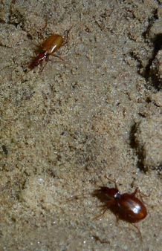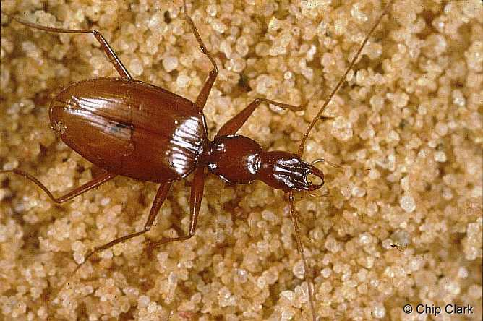

2. Taxonomic studies of spider beetles from southern Africa and Australia:

The Ptinidae is comprised of about 70 genera and over 600 species worldwide. The faunas of Southern Africa and Australia in particular include many species that have yet to be documented. This includes many taxa representing new genera- distinct lineages supported with phylogenetic evidence. South Africa is particularly rich in spider beetle diversity, with 22 genera including 11 endemic, four introduced, and seven genera currently undescribed in our possession. The Australian fauna, in particular the myrmecophilous species that are associated with ants, include many undocumented forms. Currently samples from the Pilbara region located in the northwest Australia are being processed.

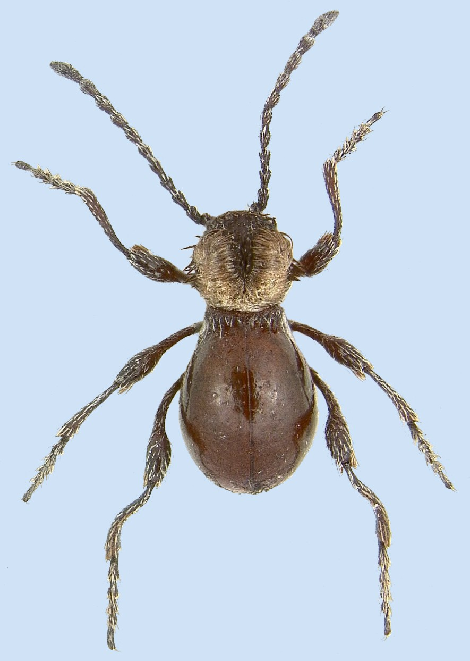

3. Molecular phylogeny of the bostrichoid beetles:

The families in the Bostrichoidea include many important timber (mainly the bostrichids) and food pests (mainly anobiids and ptinids). Many species are well known by their common names of the drugstore beetle, cigarette beetle, powder-post beetle, and the white-marked spider beetle. This diverse group contains elongate-bodied wood borers, dung feeders with globular bodies that are covered with setae of various colors, shapes and densities, pronota often with strangely shaped cavities, and highly specialized myrmecophiles with conspicuous trichomes or hair clumps on the pronotum, elytra, or legs that are designed to hold ant appeasing chemicals. There is also a species that is a thelytokous parthenogenic, but reproduces only after mating! Rampant convergent evolution in groups with similar lifestyles has made attempts at classification unnatural and hence unpredictive.
The molecular phylogeny of the Bostrichoidea project uses DNA sequence data from four genes (16s, 18s, 28s and CO1) and will clarify relationships within and among all of the families of this clade of beetles. Material to study the evolution of Bostrichoidea is being gathered via ongoing trapping programs as well as collaborators that have sent or will send material to WKU from various localities around the world. Anobiidae, Bostrichidae and Ptinidae are the main families that are studied but we are including representatives of all the families and subfamilies in the superfamily Bostrichoidea (i.e., species of Nosodendridae, and the rare endecatomine (Endecatomus) and euderiine (Euderia) bostrichids.
The student working on this project will learn all aspects of molecular systematic work- including extraction, amplification, purification, and sequencing of DNA in the Biotechnology Center at WKU. As well, tree building software will be used to construct hypotheses of evolution. Lastly, we can investigate methods such as the r8s program that can be used to assess and estimate molecular evolution and divergence times. The dispersal- vicariance analysis (DIVA) program will also be examined as a means to hypothesize ancestral taxon distributions of this fascinating group of beetles.

Anthrenus sp.
Gibbium aequinoctiale
Ptinus interruptus
Gnostus floridanus
Ptinus bimaculatus
Diplocotes foveatus
Ptinus tectus
Mezium affine
Mezium n. sp. 2
Mezium n. sp. 1
Rhyzopertha sp.
Bostrichid genus #1
Trichodesma sp.
Caenocara sp.
Anobiopsis sp.
Calymmaderus nitidus
Stegobium paniceum
Tricorynus vexatum
Oligomerus obtusus
Oligomerus sericans
Hemicoelus sp.
Euvrilletta peltata
Lasioderma serricorne
Petalium bistriatum-7
Petalium seriatum-6
Petalium seriatum-4
0.07
1.00
0.85
0.54
1.00
0.96
0.99
1.00
1.00
0.89
0.75
0.59
0.57
0.87
1.00
0.94
0.54
1.00
1.00
Gibbiinae
Ptininae
Gibbiinae
Anobiinae
Dorcatominae
Anobiinae
Dorcatominae
Anobiinae
Mesocoelopodinae
Anobiinae
Xyletininae
Dorcatominae
Ptinidae, s. s.
anobiids
Dermestidae
Ptinidae
Bostrichidae
Ptinidae

